Manila Water Company
technical specification – FORM
DD_M2C_120
Receipt Printing for FPE1- Document for Income Tax Withheld and Other Tax With Held



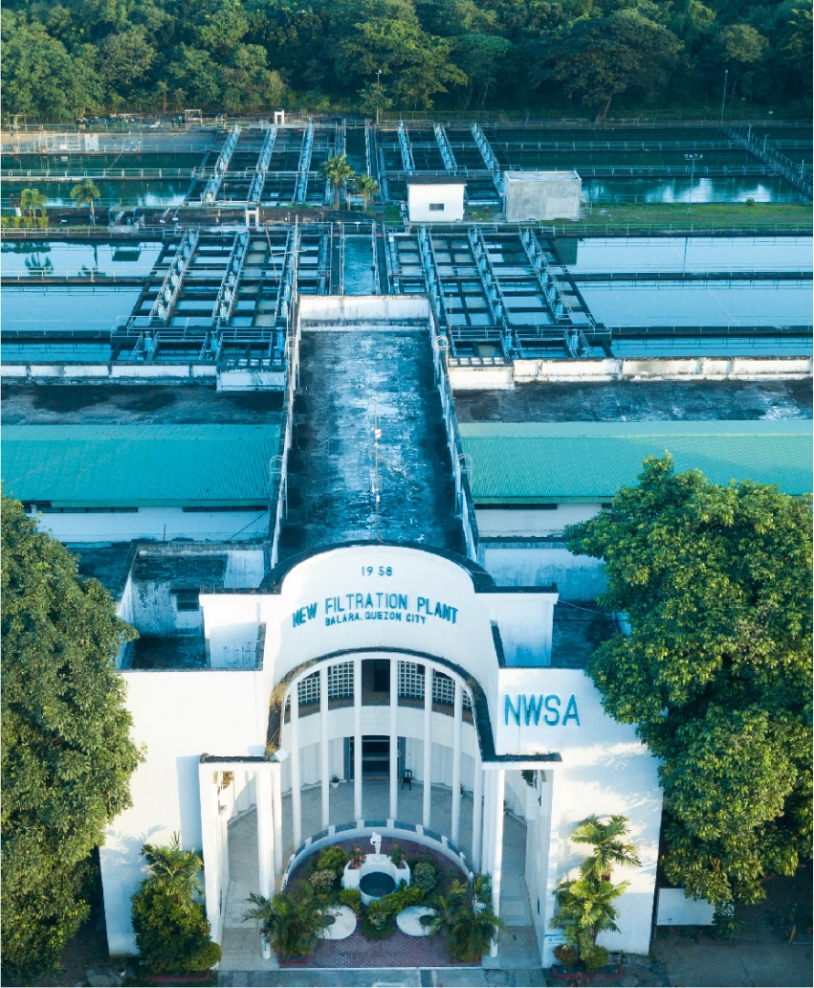
Contents
1 Document Organization 4
1.1 Document Log 4
1.2 Integration, Document Reference 4
2 Program Attributes 5
2.1 Authorization Requirements 5
2.1.1 Definition 5
2.1.2 Defined Fields 5
2.1.3 Procedure 5
2.2 Technical Flow Diagram 5
2.3 Form adjustment steps [New output management only] 5
2.4 Output Control Configuration 6
2.5 Form Processing Logic 6
3 Assumptions in Technical Design 6
4 Open Issues in Technical Design 6
5 Unit Test Results 6
6 Related Documentation 7

Document Organization
This section provides details about this document, previous version(s) of this document and the document(s) referred.

Document Log
The following table mentions the version changes and the processer(s):
Version | Status | Date | Version Created by (Name/E-Mail/Company) | Role | Comments
 | Ready for Review | May 3, 2025 | Kritika Kumawat | Author
 | Choose an item. | Click here to enter a date. |  | Choose an item.

Integration, Document Reference

S. No. | Referred Document Name | Referred Document Version | Referred Document URL (Optional)

Program Attributes
Form title
Form Name | ZAF_M2C_FICA_REC_PRINT
Package | ZS4_MWC_M2C_FICA
Print/Driver Program
Form Interface | ZIF_M2C_FICA_REC_PRINT
Fragment Details
Gateway Service
Smart Style/Script Style
Logo Name | Logo Based on Company Codes
Function Module Name

Authorization Requirements

Definition
This form can be printed in Real time at the cash desk while customer paid their bills.
If the customer paid their bills at Payment facility in that case customer visit the MWC branch/location and requested for Receipt. In that case the MWC agent will print the receipt.

Defined Fields
N/A

Procedure
Two structures are given as input in which one contains Document number and other related information (Header Data in Open Item Accounting Document) while another one has print data.
The form will be generated with the details on the given structure data.

Technical Flow Diagram

Form adjustment steps [New output management only]
N/A

Output Control Configuration
N/A

Form Processing Logic
• Company Code Name
Extract the company code (BUKRS) from the document number and retrieve the corresponding company name (BUTXT) from T001.
• Logo
Display a fixed logo based on the company code.
• Address
Fetch the business place address by retrieving the ADRNR from J_1BBRANCH and using it in the ADDR_GET_COMPLETE FM to get the full address.
• Official Receipt Number
Use the payment document number to get the receipt number (EXBEL) from the DFKKEXTDOC table.
• Date
Display the document and posting date from the DFKKZP table.
• Payor/Business Name
Use the document number to get the business partner (GPART) from DFKKOP and retrieve the partner's name (NAME_ORG1, NAME_ORG2, NAME_ORG3) from BUT000.
• Address (Business Partner)
Fetch the business partner address (house number, street, postal code, etc.) from BP_ADDRESS fields in the system.
• TIN (Tax Identification Number)
Get the tax ID by passing the BP number to the BUT0ID table with TYPE=ZID007 to fetch the ID number.
• Contract Account Number
Retrieve the contract account number from DFKKOP-VKONT.
• Bill Date
Display the payment date, which is the date the document was posted.
• Collector/Cashier
Show the name of the user (collector or cashier) by matching their user ID to their first and last names.
• OSCA/PWD ID NO
Leave this field blank.
• SC/PWD Signature
Leave this field blank.
• Nature of Collection
This is a fixed text field indicating the nature of the collection.
• Amount
A fixed text field showing the amount involved in the transaction.
• Water Revenue
Display "Water Revenue" if the payment is related to water charges based on the HVORG field (0100, 0200, 0300). If it's for Misc Charges, show "Misc Revenue."
• Vatable Sales
Calculate vatable sales based on specific conditions involving KOFIZ, HVORG, TVORG, and MWSKZ. Deduct tax amounts if applicable.
• VAT Exempted Sales
Calculate VAT exempted sales based on similar logic to vatable sales but without VAT.
• VAT Zero Rated
Calculate the zero-rated VAT sales using specific criteria for the document and related fields.
• VAT
Fetch VAT amounts based on the logic for vatable sales (MWSKZ = O3), and calculate the VAT for each sale.
• Govt Taxes
Fetch government taxes by using the same logic as for VAT sales, but including various tax types (H1-H5, M-M5, R1, F1-F4, etc.).
• Net of VAT
Sum the VAT sales, VAT exempted sales, and VAT zero-rated sales to calculate the net amount of VAT.
• Total Sales (VAT Inclusive)
Sum the vatable sales, exempted sales, zero-rated sales, and VAT to calculate the total inclusive sales.
• Less Income Tax Withheld
Deduct income tax withheld based on the payment details.
• VAT Withheld
Deduct VAT withheld based on specific criteria and tax information.
• SC/PWD Withheld
Deduct withheld amounts for Senior Citizens or Persons with Disabilities based on document details.
• Total Amount Paid
Show the total amount paid from DFKKZP, considering any excess payments or clarifications.
• Payment Mode
Identify the payment method (Cash, Check, or Other) based on the payment type codes (e.g., CS for cash, CH for check).
• Amount in Words
Convert the total amount into words using a function to display the amount in written form.
• Bank/Card Number
Fetch the bank or card number from the CHCKN field in DFKKZP.
• Check/Card Number
Retrieve the check or card number from the INFOF field in DFKKZP.
• Date (Receipt Printed)
Display the date when the receipt was printed.
• Series Range, Permit No., Effectivity Date
Display a fixed text for series and permit numbers, with an effectivity date (e.g., May 17, 2023).
• Print Name and Signature & Watermark of Logo
Add the printed name and signature of the responsible person along with the watermark of the company logo.

Assumptions in Technical Design
N/A

Open Issues in Technical Design
N/A

Unit Test Results

Scenario # | Input Selection Criteria | Expected Result | Actual Test Pass/Fail
1. | MWC user post the WHT amount for the available invoice document through FPE1. | Document should post the document type VW, and GL accounts are 1101101003,  1101101001 Dr. and customer account is Cr. | Pass
2. | Print the WHT document through FPE3 | Enter the WHT document and select print option or (CTRL+P), spool should generate for the same. | Pass
3. | Select the relevant spool from the list and print the document | User should get the spool request in SP01. And print it. | Pass

Related Documentation

Template Version

Version | Status | Date | Version Created by (Name/E-Mail/Company) | Role | Comments
1.0 | Final | February 11, 2019 | Abhishek Nayak | Author
 | Choose an item. | Click here to enter a date. |  | Choose an item.

